**Analysis Of Public Perception During Lockdown Due To Coronavirus**

Piyush Chabbra*, Ayushya Nirwan*, Jigyasa Chaudhary*, Abhiraj*, Dr. Hoor Fatima*

*(Department of Computer Science, Sharda University, Greater Noida

Email: hoor.fatima@sharda.ac.in)

**ABSTRACT**

Nowadays, the usage of the internet among individuals has increased a lot when compared with earlier days. As technology increases rapidly, the evolution of artificial intelligence has taken place. SARS-CoV-2 the current an ongoing pandemic around the world since 2019 and the World Health Organization declared that the countries should take appropriate measures to control this pandemic situation. From 24th March 2020, the government of India imposed a nationwide lockdown in order to prevent the most hazardous virus for humans. In skin cancers, melanoma type is most dangerous to humans. The lockdown restricted the people to stick into the. All roadways, railways, waterways, and airways are restricted with exceptions for transportation of essential merchandise and even have exceptions for fire, police, and emergency services. instructional institutions, industries, and cordial reception services were additionally going beneath this lockdown, Thousands across India are started to share their opinions regarding the impose of lockdown during the pandemic in microblogging sites like Twitter, Koo, etc. Sentiment analysis, which is a part of machine learning, has become one of the foremost common fields of language process (NLP). We can capture people's reactions to an incident by utilizing the capabilities of sentiment analysis. required to extract such material to investigate people's feelings would possibly play a key role once creating changes to stay the matter underneath control. The goal of this study is to elicit Indian individuals' opinions on the broad internment obligatory by the govt. of India to lower the frequency of Coronavirus spread. The sentiment analysis of tweets was accomplished during this work utilizing NLP and machine learning classifiers. data are retrieved from Twitter, annotated exploitation Text Blob and language tool package equipped with Python served as a preprocessor. During this research, RNN is used to classify sentiment. consistent with the findings of this poll, the bulk of Indian residents settle for the Indian government's call to impose internment throughout the corona outburst.

***Keywords*** **-**Convolutional Neural Network, Deep Learning, Character, Segmentation.

**1. INTRODUCTION**

The explosive outbreak of Coronavirus infection (COVID-19), which commenced in Wuhan, China, has generated a local and global public fitness disaster [1]. The Centers for Disease Control and Prevention (CDC) activated its Emergency Operations Center (EOC), and on January 20, 2020, the World Health Organization (WHO) issued its first file at the situation of Coronavirus ailment 2019 (COVID-19) [2]. The WHO recognized and named the brand-new Coronavirus "2019-nCOV." Influenza COVID-19 was underestimated by the National Health Commission (NHC) until the Commission formally classified it as an infectious disease of the B-kind on January 20, 2020 [3]. The World Health Organization labeled it a global medical crisis on January 30, 2020. COVID-19 attacks both humans and animals, causing havoc on their respiratory, digestive, liver, and cerebral systems. As of 14 April 2020, the World Health Organization (WHO) recorded 1,812,734 instances and 113,675 deaths in 213 countries. COVID-19 instances are on the rise because of a lack of medicine and immunizations, as well as the fact that it is passed from person to person via direct contact, coughing, or sneezing.

In the lack of immunization for these contagious diseases, the most cost-effective approaches towards becoming safe are prudence and social distancing. Social distance is an important method of limiting the spread of the COVID-19 pandemic, where distinct physiological distancing limits are used to combat COVID-19. People are encouraged to remain at home and maintain social distance. Mostly every country implemented a shutdown to guarantee social isolation in public spaces. In the period of mankind’s civilization,there never has been a period when a lockdown has been imposed on the entire planet. The lockdown is an emergency technique that prevents people from free movement in public places[7].

COVID-19 is generally detected 2 to 14 days after the influenza virus, and the symptoms can range from mild to moderate, potentially leading to death. In a very short period of time, new coronaviruses have emerged as a major worldwide concern[8]. Since its discovery in the first week of December 2019 in Wuhan, Hubei People's Republic Of China, it has spread to 213 nations, with a substantial amount of instances confirmed from the United States, Spain, Italy, Germany, France, the United Kingdom, China, Iran, Turkey, Belgium, The Netherlands, and Switzerland.

Nevertheless, nations are still reporting new COVID-19 instances and India is one among them[9].

As a result of COVID-19, the globe is confronting exceptional problems. Research teams, scientists, and the clinical network are certainly running to increase a vaccine or medicinal drug in opposition to this because, even though there was development in acknowledging the virus, prevention, and medication, severe psychological, cognitive, and social monetary adjustments that society is presently experiencing. Furthermore, preceding studies has proven that below those occasions and the epidemiological scenario, humans are liable to emotional problems, intellectual fitness crises, dread, and anxiety, all of which impair their coping strategies. In summary, while the universe is centered on growing COVID-19 flu vaccine and drugs, we can also additionally have come to be oblivious to the social behavior that exists inside countries, because the pandemic has multidimensionality that consists of difficult science, this means that expertise the sociocultural elements of conduct. The Government of India has followed lockdown as a precautionary measure, and it's far important to apprehend how the extensive majority of the populace is reacting to the contemporary scenario. As India is one of the globe's biggest and maximum populated countries, with the best inner migration rate, a huge geographical region, and healthcare difficulties, the contemporary attempt intends to discover the network conduct sample to COVID-19 lockdown in India. When managing an endemic in this sort of extensive country, it's far more important to apprehend the societal behavioral responses, as human beings are capacity for viral spreaders. As a result, expertise in the Indian public's response to the pandemic is important. The purpose of this essay is to recognize the network's behavioral reaction to the COVID-19 lockdown in India. To accomplish this purpose, the authors first tested the efficacy of lockdown in India and reviewed authorities’ measures throughout COVID-19. Second, on this framework, Introduction changed into mentioned in phase 1. Related paintings might be mentioned in phase 2, phase three describes approximately our proposed paintings and phase four affords Results for our proposed paintings and phase five will finish this paper[7].

# **2. Related work**

This study examines the use of machine convolutional neural networks in the work related to covid-19 and lockdowns. The model achieved the best accuracy of using Recurrent Neural Networks. The training and testing dataset were captured from the system or uploaded to the system.

Recent developments in machine learning-based RNN[13] have allowed researchers to greatly improve the accuracy of the work. In this a machine learning-based approach to detect the sentiment using the feature extraction from the powerful libraries captured in real-life scenarios with heterogeneous backgrounds and experimented with convolutional neural networks on our large dataset. Machine learning offers a number of possible uses in clinical trials and studies. As anyone in the telecommunications business will tell you, using microblog data to understand citizens' sentiments is challenging. Using ML-based predictive analytics to anticipate probable outcomes might assist governments in drawing a better pool from a diverse set of tweets from social media, for example. Machine learning has also been used to ensure real-time monitoring and data access for trial participants, as well as to determine the appropriate sample size to be tested and to use the potential of electronic records to eliminate data-based mistakes. Here is an algorithm for sentiment extraction and technique which is used in the Twitter dataset and classified for the best. Where the AI sector is something on which the economy of our country is highly dependent. Here the government needs to understand the feelings and to control the pandemic as per the citizens. If proper care is not taken in this area then it causes serious effects on the citizens of the country.

Based on the above-related works, we have implemented a system using Machine Learning. The next sections will describe our proposed work.

|  |  |  |
| --- | --- | --- |
| **Author & Year** | **Proposed** | **Finding/Outcomes** |
| Wu, Jianhong & Leung, Kathy & Leung, Gabriel[10] | Nowcasting and Forecasting the Potential Domestic and International Spread of the 2019-nCoV Outbreak Originating in Wuhan, China | We assess the scale of the outbreak in Wuhan depending on the number of instances transmitted from Wuhan to places from outside mainland China, and we project the magnitude of both the national and worldwide public health impacts for outbreaks, taking into consideration social and non-pharmaceutical preventative strategies[10]. |
| Medford, Richard & Saleh, Sameh & Sumarsono[2] | Leveraging High-Volume Twitter Data to Understand Public Sentiment for the COVID-19 Outbreak | Tweets with bad opinions and emotions correspond to the number of instances reported mostly in the COVID-19 epidemic. Twitter is a useful channel for understanding public opinion throughout actual time and targeting public health messaging depending on user interest and sentiment. |
| Li, Sijia & Wang, Yilin & Xue, Jia & Zhao[3] | The Impact of COVID-19 Epidemic Declaration on Psychological Consequences | The findings revealed that negative emotions (including anxiety, despair, and anger) and susceptibility to social hazards increase, whereas good emotions (such as Oxford happiness) and life satisfaction are reduced. |

**Table 1:** An overview of related works

# **3. Methodology**

* This section describes clearly how our system was developed.
  + Firstly, to perform the operation we need a dataset related to tweets. We collect a Twitter dataset related to the covid-19 lockdown imposed across India. After preparing the dataset, we will perform the preprocessing on the prepared dataset.
  + Once the dataset is prepared and preprocessed, we upload our dataset into the model.
  + After uploading data, we perform necessary feature engineering techniques on the considered dataset. In this step, we remove noise from the data and split the dataset into train data and test data.
  + We will apply a few NLP techniques in order to convert the dataset into machine understandable format and then we will obtain the sentiments for the particulars.
  + In the training process, we built our proposed network with the help of Neural Networks from TensorFlow. Here, we are using a machine learning model.
  + The proposed RNN architecture is based on Neural Networks. The proposed model is built using neurons from TensorFlow.
  + Here the proposed model mainly classifies the tweets as positive, negative, or neutral to the lockdown based on this proposed model classification.

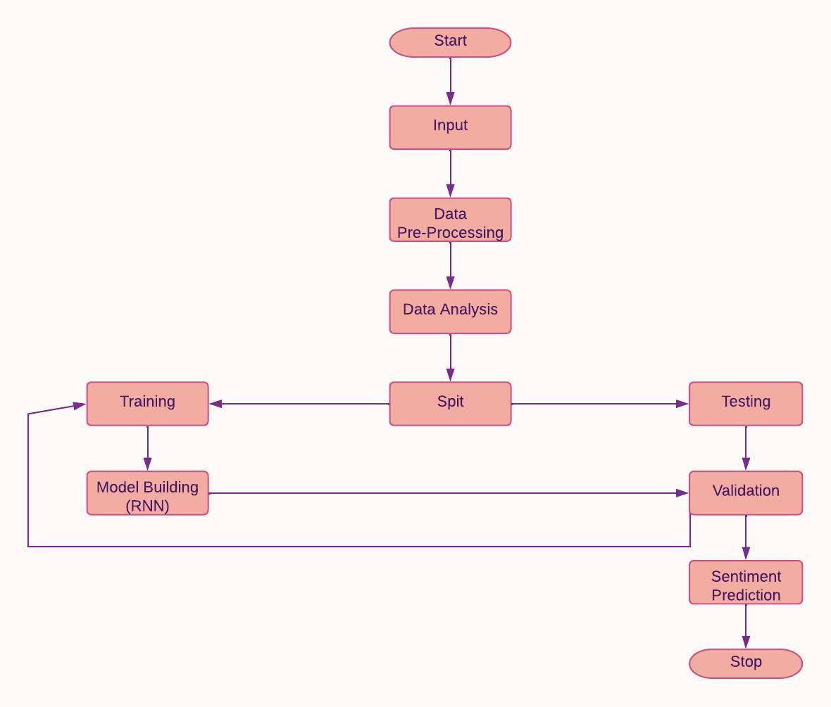

**Fig 1.** Block diagram of the proposed method

**3.1 Natural language processing (NLP)**

Natural language processing allows computer systems to talk with human beings in their local language even as additionally automating diverse language-associated processes. NLP, for instance, allows computer systems to study textual content, listen to the voice, examine it, gauge sentiment, and perceive which bits are significant. Computers can now interpret extra dialect facts than humans, without turning into fatigued and in a consistent, unbiased manner. Given the huge quantity of unorganized records created daily, from healthcare notes to media platforms, automation can be critical for efficiently studying textual content and audio records. Language studying is awe-inspiringly complex and nuanced. We can explicit ourselves orally and in writing in countless type of ways. There are numerous languages and dialects, each with its own personal set of grammatical and syntactic rules, vocabulary, and terminology. We mechanically misspell, truncate, or pass over punctuation whilst we write. When we speak, we've got local accents, stutter, stammer, and use vocabulary from many a couple of languages.

While supervised and unsupervised learning, particularly profound learning, are now used for modeling human language, semantic and syntactic interpretation, as well as domain knowledge, will continue to be required, which current machine learning approaches cannot always supply. NLP is important because it allows for the resolution of linguistic ambiguity and provides quantitative order to data in a range of application areas such as speech recognition and text analytics.

Natural language processing encompasses a wide range of tools for detecting human language, including statistical and machine learning approaches, as well as rule-based and algorithm-based approaches. We require a diverse set of techniques since text- and voice-based data, as well as actual applications, vary greatly.

Tokenization and parsing, lemmatization, stemming, part-of-speech, language recognition, and linking signals are all basic NLP activities. You've done these chores manually previously if you've ever diagrammed sentences in grade school.

NLP activities, in general, decompose language into smaller, essential components, attempt to understand their connections, and examine how those components interact to represent meaning.

**3.2 Neural Networks:**

• A Neural Network is created of multiple layers that are coupled along to figure out the structure and performance of the human brain. It is learning from vast amounts of knowledge and using difficult algorithms to be coached.

• As an example, a neural network will acknowledge a dog breed supporting its characteristics.

• The neural network’s input layer receives picture pixels from 2 completely different dog breeds. The image pixels are later processed for feature extraction within the hidden layers.

•Based on the output layer, the dog can either be a German shepherd or a Labrador.

•A network like this doesn't wish to store its previous output.

* Several neural networks can assist in the resolution of various business difficulties. Let us have a look at a few of them.

**3.3.Recurrent neural networks (RNN)**

Recurrent neural networks retain the result of a certain layer and use it to predict its output.

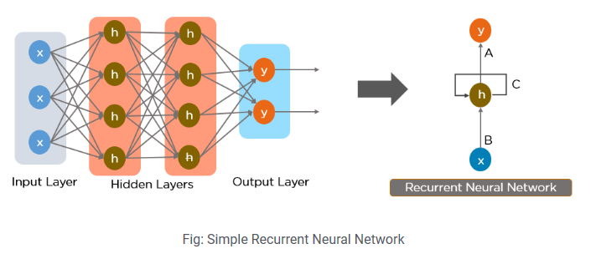

**Fig 2**.Simple recurrent neural network

In a feed-forward neural network, communication takes place only in a forward direction from input neurons to hidden layers and output nodes. The network is not cyclical or looped. A simple representation of a feed-forward neural network can be seen here:

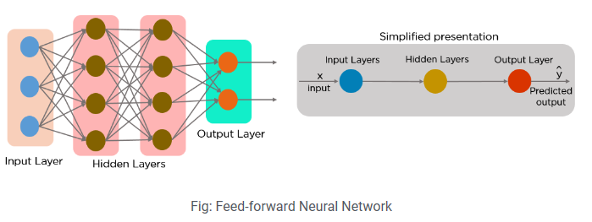

**Fig 3**.The feed forward neural network

Recurrent neural networks were developed as a result of a few flaws in the feed-forward neural network:

• Unable to process sequential data

• Analyzes only the current input

• Unable to remember earlier inputs

The Recurrent Neural Network is the solution to these problems (RNN).

An RNN may handle sequence information by accepting both current and previously received entries. Because of their internal memory, RNNs can remember past inputs.

These RNNs are mostly used in the applications of NLP, Time series, Language Translation.

# **4. Results and Discussions**

This session will discuss the results obtained by performing the above-proposed method and how they are extracted using the NLP and RNN architectures.

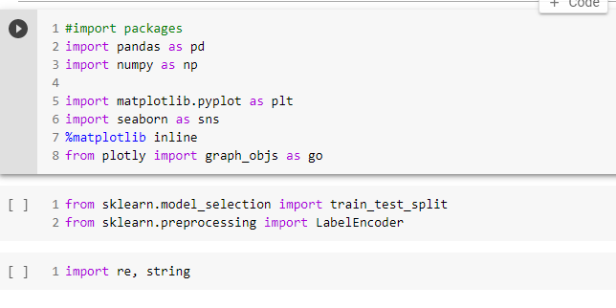

**Fig 4.** The Libraries You Will Need.

The above images represent the loading procedure of required libraries in order to implement the project.

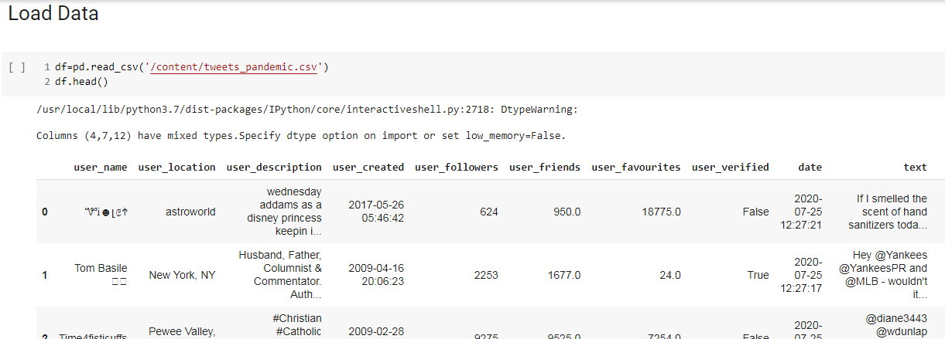

**Fig 5.** A data load is underway.

The above-shown figure is showing us how to load the data into the work environment i.e., python’s Jupyter notebook.

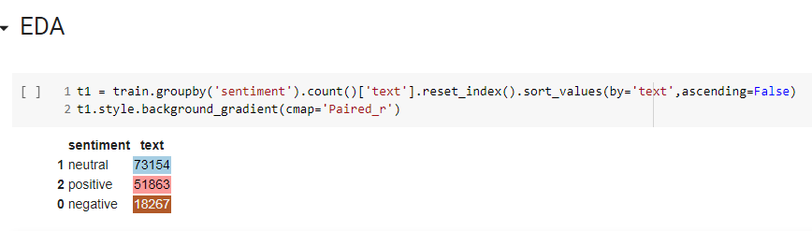

**Fig 6.** Plot of the Count.

The above-shown figure is the count plot which includes the count of positives, negatives, and neutrals in our particular column.

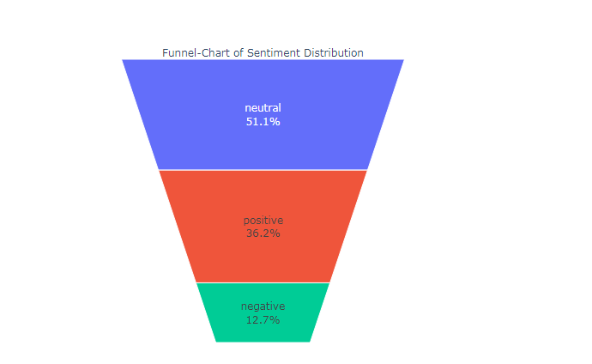

**Fig 7.**A funnel chart representing sentiment analysis

The above-shown figure is the Funnel count plot which includes the count of positives, negatives, and neutrals in our particular column with percentages.

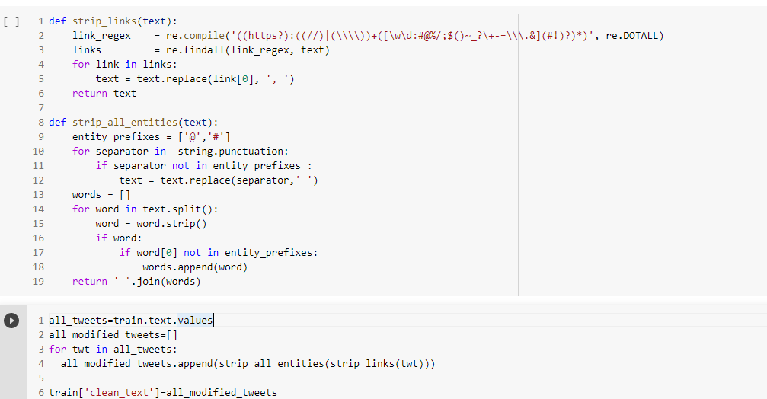

**Fig 8.** Organizing and cleaning data.

The above-shown figure is the cleaning part of data where we are removing unwanted attributes within the dataset.

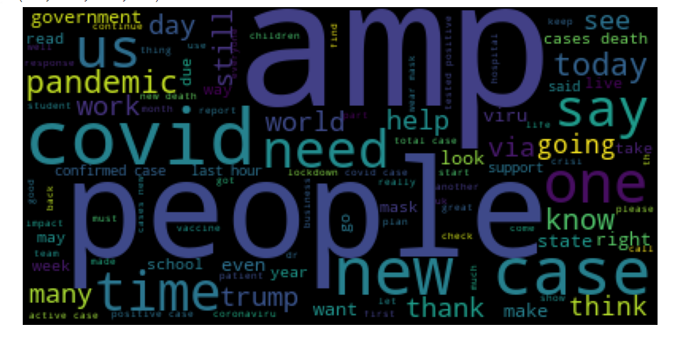

**Fig 9.** Cloud of tweets.

The above-shown figure is the Tweets cloud for our data which shows the data in a cloud representation.

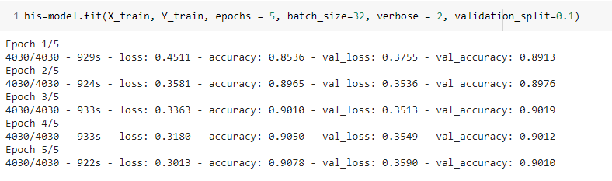

**Fig 7.** Construction of model buildings.

The above-shown figure represents the things related to model building using RNN architecture.

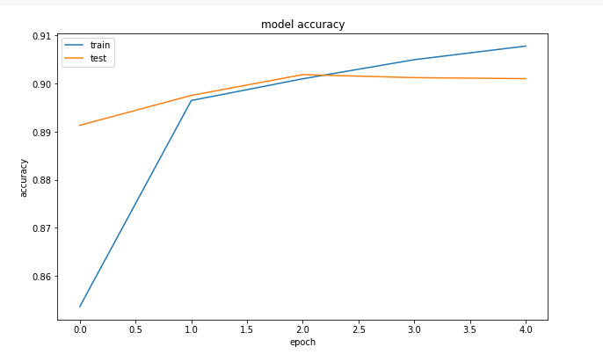

**Fig 8.**The Plot of Accuracy

The above-shown figure is the accuracy plot for a particular model built for the project.

# **4. Conclusion**

The study provides the classification of tweets using a machine learning technique. Here we used Recurrent Neural Network’s architecture (RNN) algorithm. The proposed RNN architecture is based on neural networks and is trained and tested on the dataset collected.

In this project, we will explore sentiment analysis for COVID-19 during lockdown among Indians. We used RNN for modeling purposes generating adequate emotion prediction accuracy. The emotions are classified into 3 groups positive, neutral, and negative with an accuracy of around 90%. In the future, we may consider new data for lockdown 2.0 as well and remodel it. It could act as a comparison between sentiments of lockdown 1.0 vs 2.0.

# **References**

[1] J. T. Wu, K. Leung, and G. M. Leung, “Nowcasting and forecasting the potential domestic and international spread of the 2019-nCoV outbreak originating in Wuhan, China: A modeling study,” Obstetrical Gynecology.. Surv. vol. 75, no. 7, pp. 399–400, Jul. 2020.

[2] R. J. Medford, S. N. Saleh, A. Sumarsono, T. M. Perl, and C. U. Lehmann, “An ‘infodemic’: Leveraging high-volume Twitter data to understand the public sentiment for the COVID-19 outbreak,” medRxiv, Jan. 2020, DOI: 10.1101/2020.04.03.20052936.

[3] S. Li, Y. Wang, J. Xue, N. Zhao, and T. Zhu, “The impact of COVID-19 epidemic declaration on psychological consequences: A study on active Weibo users,” Int. J. Environ. Res. Public Health, vol. 17, no. 6, p. 2032, Mar. 2020.

[4] WHO Statement Regarding Cluster of Pneumonia Cases, WHO, Wuhan, China, 2020.

[5] Baggio, M. (2020) ‘Here’s Why Society Is Reacting with Panic to Coronavirus’. : https://www.weforum.org/agenda/2020/03/dont-panic-how-human-behaviour-can-fuel-the-coronavirus/ (accessed 19 June 2020).

[6] Balinska, M. and C. Rizzo (2009) ‘Behavioural Responses to Influenza Pandemics: What Do We Know?’ PLOS Currents Influenza 1: RRN1037. Banerjee, A.V. (1992) ‘A Simple Model of Herd Behavior’, The Quarterly Journal of Economics 107: 797– 817.

[7]Prasoon Gupta, Sanjay Kumar, R. R. Suman, Vinay Kumar. "Sentiment Analysis of Lockdown in India During COVID-19: A Case Study on Twitter", IEEE Transactions on Computational Social Systems, 2021

[8]Biao Tang, Nicola Luigi Bragazzi, Qian Li, Sanyi Tang, Yanni Xiao, Jianhong Wu. "An updated estimation of the risk of transmission of the novel coronavirus (2019-Nov)", Infectious Disease Modelling, 2020 .

[9]Sahiba Sharma, and Anubrata Paul. "COVID-19 India: An insight into the impact of lockdown and community behavioral response" International Social Work, 2020.

[10] Joseph T Wu, Kathy Leung, Gabriel M Leung. "Nowcasting and forecasting the potential domestic and international spread of the 2019-nCoV outbreak originating in Wuhan, China: a modeling study", The Lancet, 2020.

[11] Kyunghyun Cho, Bart van Merrienboer, Caglar Gulcehre, Dzmitry Bahdanau, Fethi Bougares, Holger Schwenk, Yoshua Bengio,” Learning Phrase Representations using RNN Encoder-Decoder for Statistical Machine Translation”

[12] AlexSherstinsky “Fundamentals of Recurrent Neural Network (RNN) and Long Short-Term Memory (LSTM) network”

[13] Junhua Mao, Wei Xu, Yi Yang, Jiang Wang, Zhiheng Huang, Alan Yuille, “Deep Captioning with Multimodal Recurrent Neural Networks (m-RNN)”

[14] Emma Strubell, Ananya Ganesh, Andrew McCallum, “Energy and Policy Considerations for Deep Learning in NLP”

[15] ChengXiang ZHAI, Jing JIANG, University of Illinois at Urbana-Champaign,” Instance Weighting for Domain Adaptation in NLP”

[16] Zsolt Ugray, Leon Lasdon, John Plummer, Fred Glover, James Kelly, Rafael Martí, “Scatter Search and Local NLP Solvers: A Multistart Framework for Global Optimization”

[17] Klaus Greff; Rupesh K. Srivastava; Jan Koutník; Bas R. Steunebrink; Jürgen Schmidhuber,“LSTM: A Search Space Odyssey”

[18] Martin Sundermeyer, Ralf Schluter, and Hermann Ney, “LSTM Neural Networks for Language Modeling”, Human Language Technology and Pattern Recognition, ComputerScience Department, RWTH Aachen University, Aachen, Germany

[19] “Doctor explains why white fungus is ‘more dangerous’ than black fungus,” https://indianexpress.com/ article/lifestyle/health/white-fungus-covid-doctor-explains-why-more-dangerous-than-black-fungus-7323224/, last accessed: 28 June, 2021.

[20] “Government ready for 14-day shutdown after ntac recommendation,” https://www.dhakatribune.com/ bangladesh/2021/06/24/covid-19-advisory-committee-recommends-nationwide-lockdown-for-2-weeks, last accessed: 28 June, 2021.

[21] “Lockdown: Govt announces nationwide strict shutdown from monday for aweek,”https://www.thedailystar.net/frontpage/news/lockdown-2118105, last accessed: 28 June, 2021.

[22] V. Pandey, “Covid-19 in india: Patients struggle at home as hospitals choke,” https://www.bbc.com/news/ world-asia-india-56882167, last accessed: 28 June, 2021.

[23] D. A. Putri, D. A. Kristiyanti, E. Indrayuni, A. Nurhadi, and D. R. Hadinata, “Comparison of naive bayes algorithm and support vector machine using pso feature selection for sentiment analysis on e-wallet review,” in Journal of Physics: Conference Series, vol. 1641, no. 1. IOP Publishing, 2020, p. 012085.

[24] S. A. Mahtab, N. Islam, and M. M. Rahaman, “Sentiment analysis on bangladesh cricket with support vector machine,” in 2018 International Conference on Bangla Speech and Language Processing (ICBSLP). IEEE, 2018, pp. 1–4.

[25] M. Guia, R. R. Silva, and J. Bernardino, “Comparison of na¨ıve bayes, support vector machine, decision trees and random forest on sentiment analysis.” in KDIR, 2019, pp. 525–531.